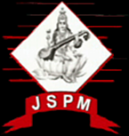 | JSPM’s  RAJARSHI SHAHU COLLEGE OF ENGINEERING  TATHAWADE, PUNE-33  (An Autonomous Institute Affiliated to Savitribai Phule Pune University, Pune) | 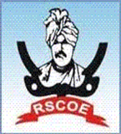

- Statement of Clear Goal, Use of appropriate methods, Significance of results, Effective presentation

Name of the Course: Operating Systems
Name of the Faculty: Prof. Taniya Bhattacharjee
Name of the Innovative Method used: Case Study
Name of the topic: Process/Thread Synchronization & Mutual Exclusion.

Statement of Clear Goal: To help students understand topics better by using Case Studies in teaching, so they can review difficult concepts, and enjoy learning through solving real time problems.
Significance of result: After solving the Case Studies, students were able to understand the topic more clearly, remember key points better, and showed improved participation and performance in related activities or assessments.

Effective Presentation (Screenshot):
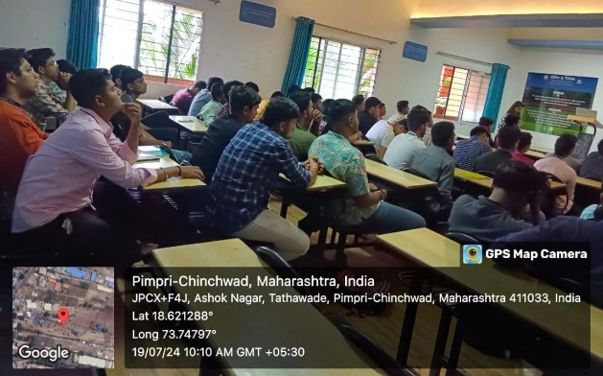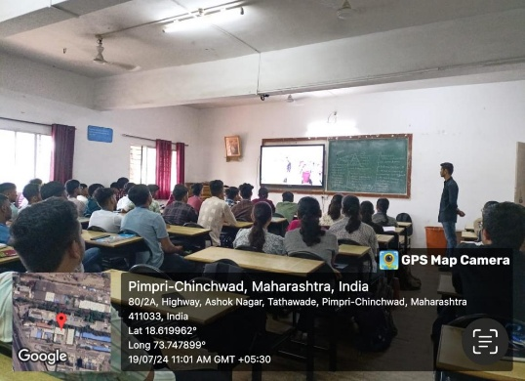

Peer Review and Critique (Feedback):

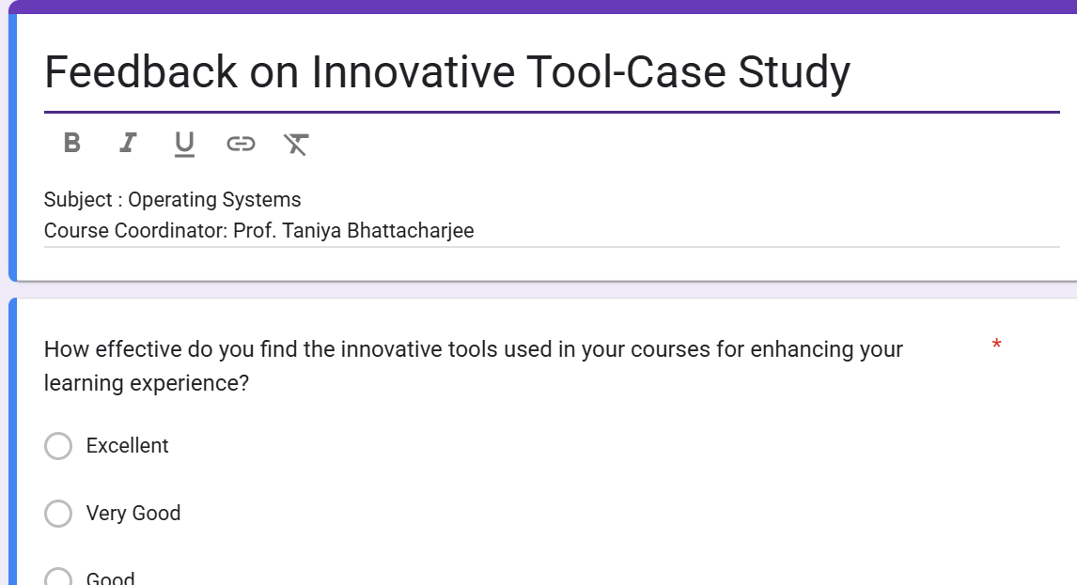

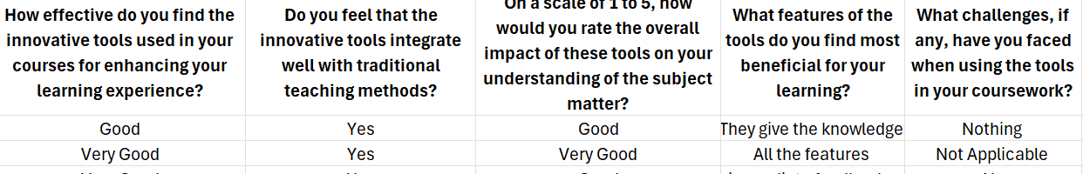

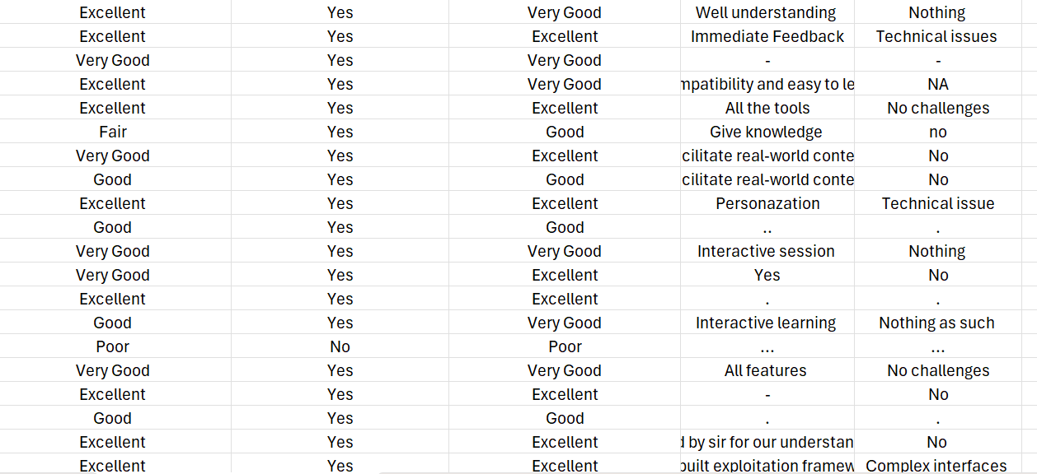

- Availability of work related to Innovation by Faculty in Teaching and Learning is on Institute website.

https://www.jspmrscoe.edu.in/information-technology/innovation-practices

- Availability of work for peer review and critique.

Work is available for peer review and critique on github.

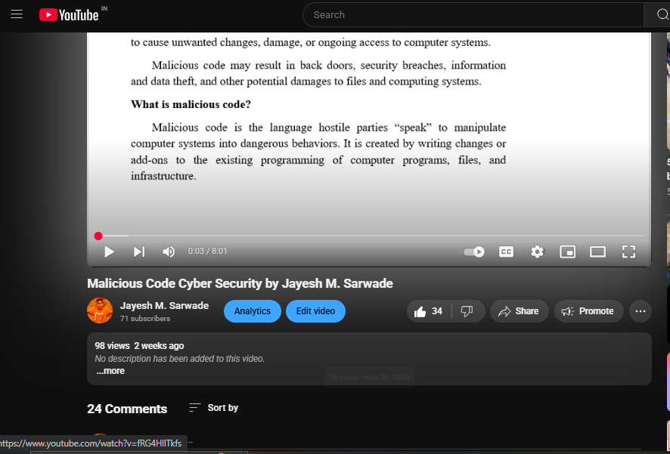

D: Reproducibility and Reusability by other scholars for further development

- Views, likes, comments, and shares: People are engaging with and potentially applying the content.
- Students are forwarding video to other for watching
- Students are giving Comments
- Viewers are thinking critically and considering extensions
- This video is linked to GitHub repositories. Viewers can download and can modify it.
The link of github repository is as follows:
https://github.com/users/jayeshsarwade/projects/1/views/1?layout_template=table

Sr.No | Innovation Used by | Details of User | Purpose of  Reproducibility and Reusability
1. | YouTube Video | Dr. Jayesh M. Sarwade | To allow viewers to repeat the process or concept shown in the video and obtain the same results.  To. Encourage knowledge sharing and collaboration.

Course Co-ordinator Module Co-ordinator HOD

Dr. Jayesh M. Sarwade Dr. S.M. Chaware Dr. Nihar M. Ranjan

